**A Nonlinear, 6 DOF Dynamic Model of an Aircraft: The Research Civil Aircraft Model (RCAM)**

**Introduction:**

The aircraft is a twin engine, commercial aircraft (Similar to the specs of a Boeing 757-200 which is also a twin-engine aircraft).

***Our focus will be in generating the “Plant Model of the aircraft”. The GARTEUR documentation covers the plant model, sensor model, controls design and more.***

**Plant model:** Rigid body model of the aircraft

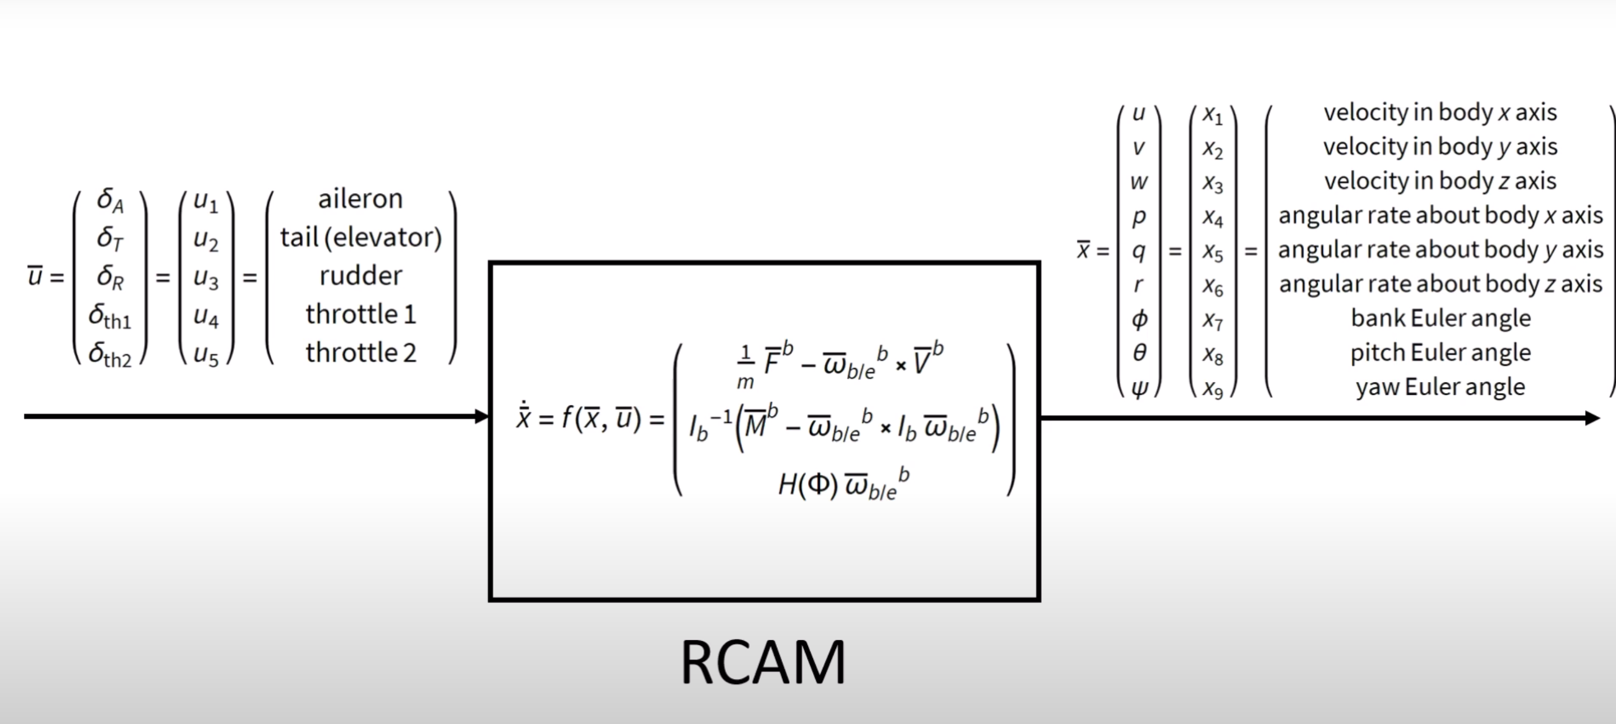

**NOTE:** u2 is the entire horizontal tail deflection and not just the elevator deflection.

A set of 10 steps are to be followed to model the Plant Model of the flight and they are:

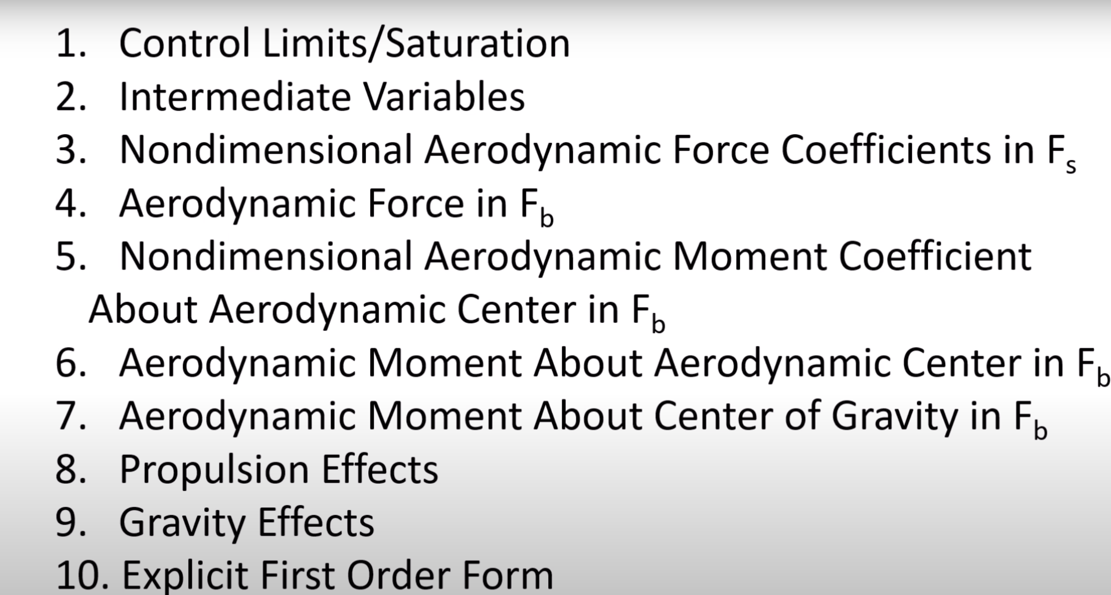

1. **Control Limits/Saturation:**

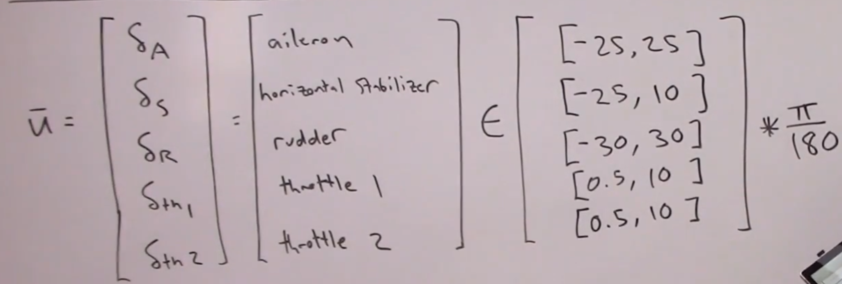

This basically deals with the limits on the control surface deflections. (u1 to u5)

***Assumption:***

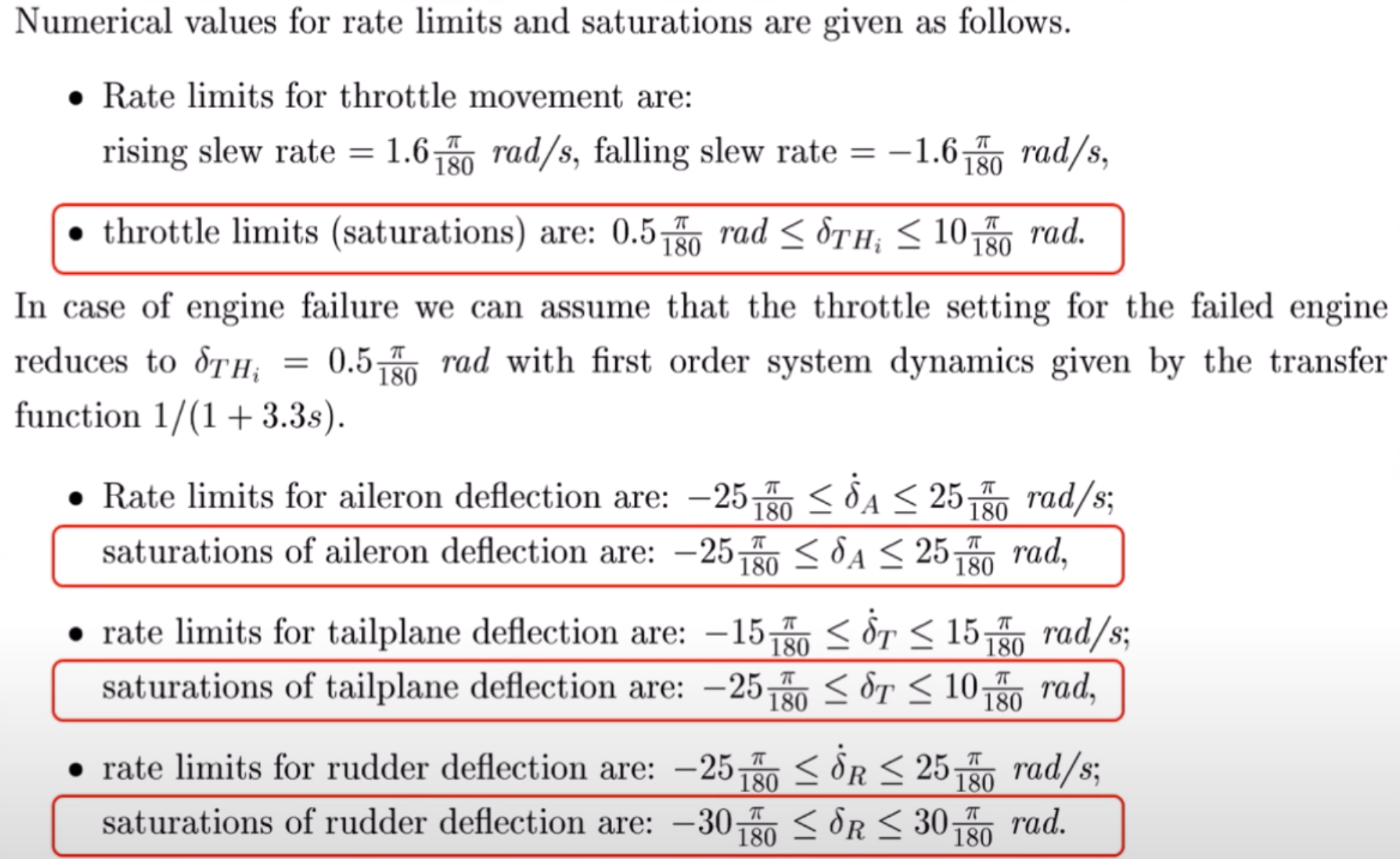

In reality the rates of these control surface deflections are also considered while modelling the aircraft, but to reduce the number of states to ease the calculation we are neglecting the rate of change of these control surface deflections.

The ones marked in red are the control limits ranges.

1. **Intermediate Variables:**

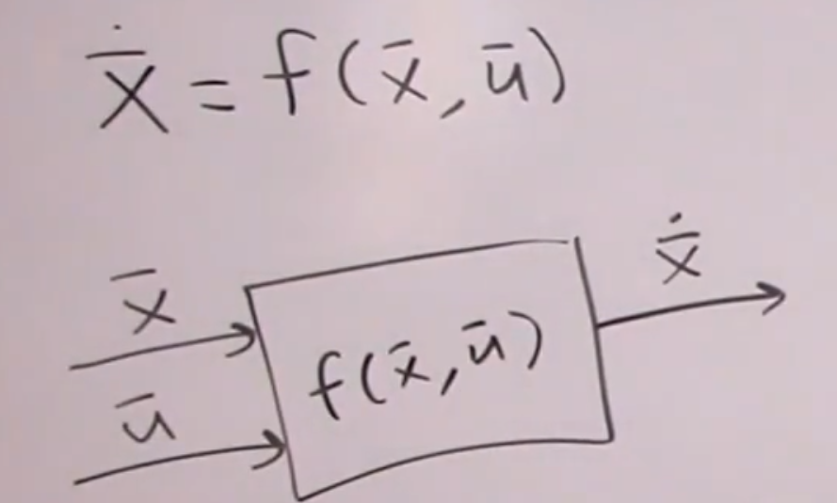

The main purpose of this step is to represent the state rate of change as a function of control surface deflections as well as state variables.

Let’s see how some of the terms can be expressed as f ($\overline{x}$, $\overline{u}$):

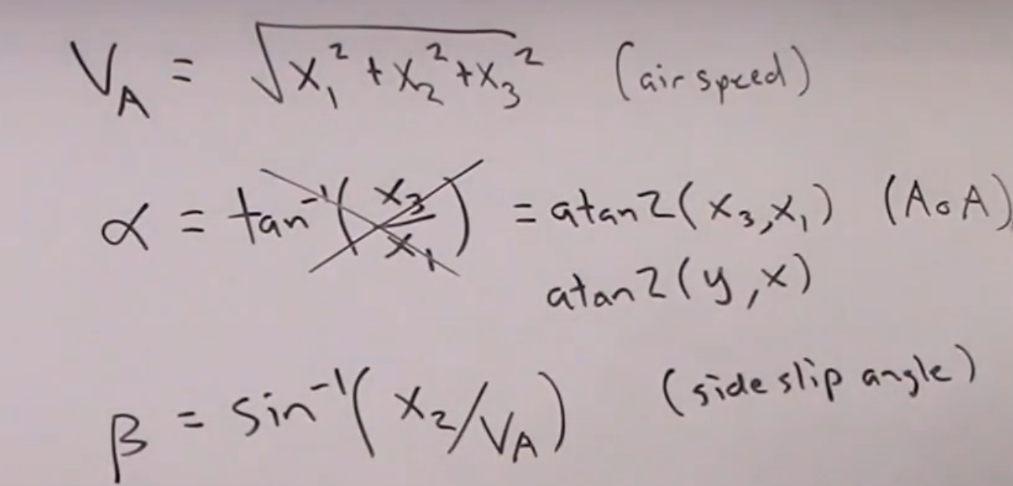

**NOTE:** For α, arctan2 is taken because arctan will show some problem in the domain and we won’t get the required result according to our expectation.

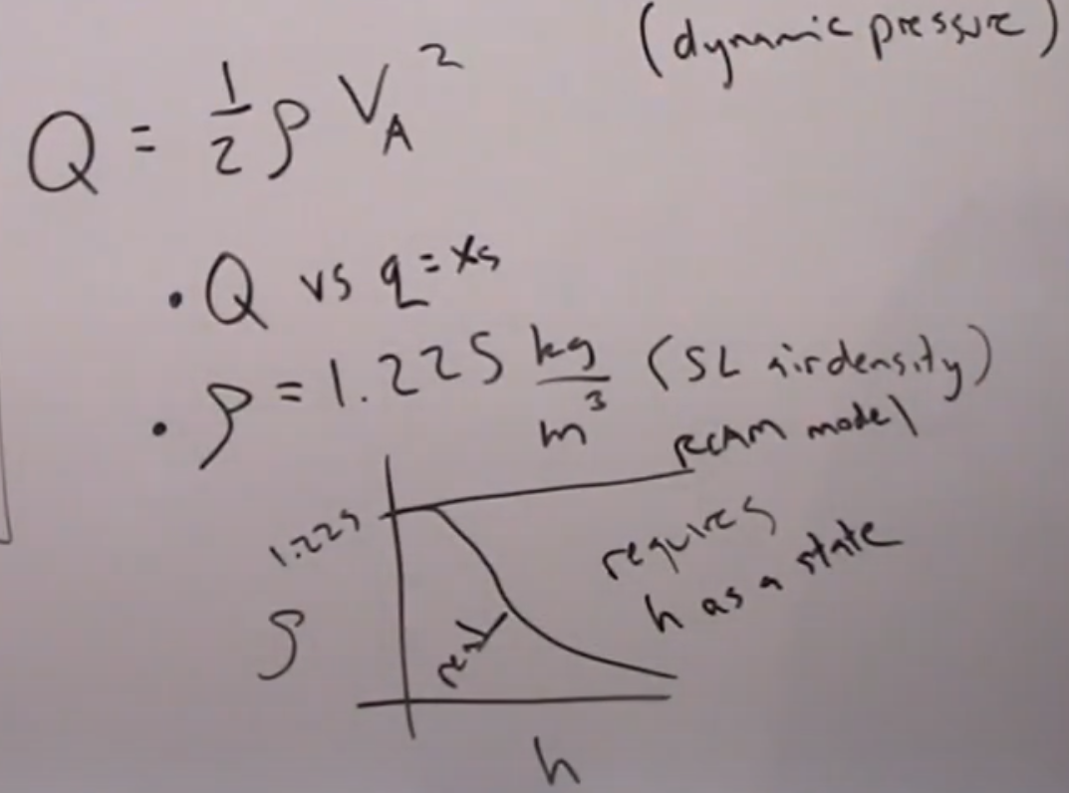

**NOTE: Q:** Dynamic Pressure, **q:** Angular Rate about y-axis (x5)

***Assumption:***

The density is considered to be constant as if it isn’t we will have to add another state which is the altitude of the aircraft (h).

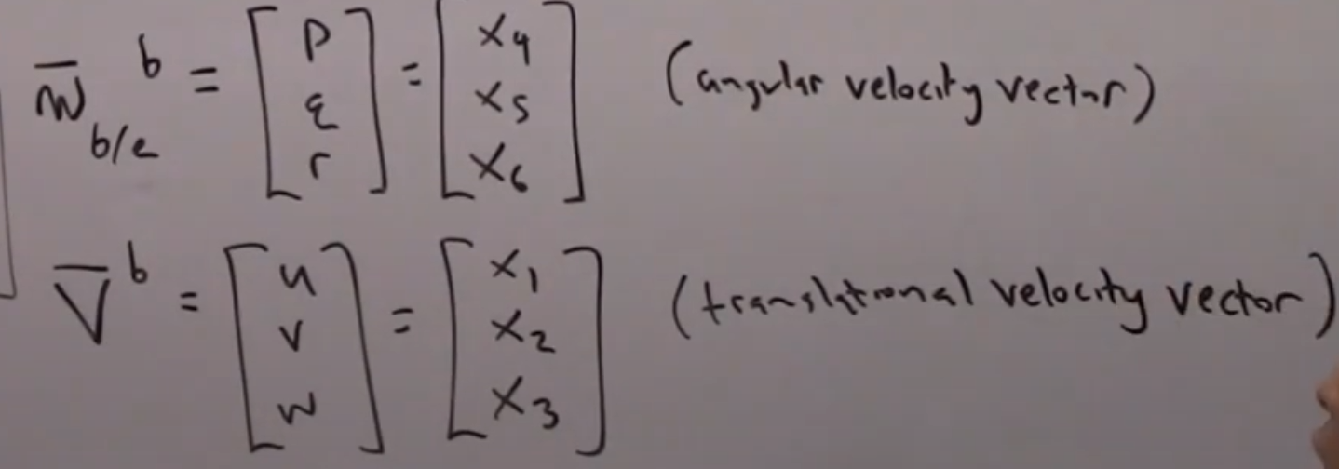

${\overline{ω}}_{b/e }^{b}$**:** Angular velocity of the body with respect to the earth when expressed in the body frame.

${\overline{v}}^{b}$**:** The velocity of the centre of mass of the aircraft when expressed in the body frame.

1. **Non – Dimensional Aerodynamic Force Coefficients in $F^{S}$ (Stability frame):**

The reason for using the stability frame can be seen below as stated in section 2.3.4 in RCAM documentation.

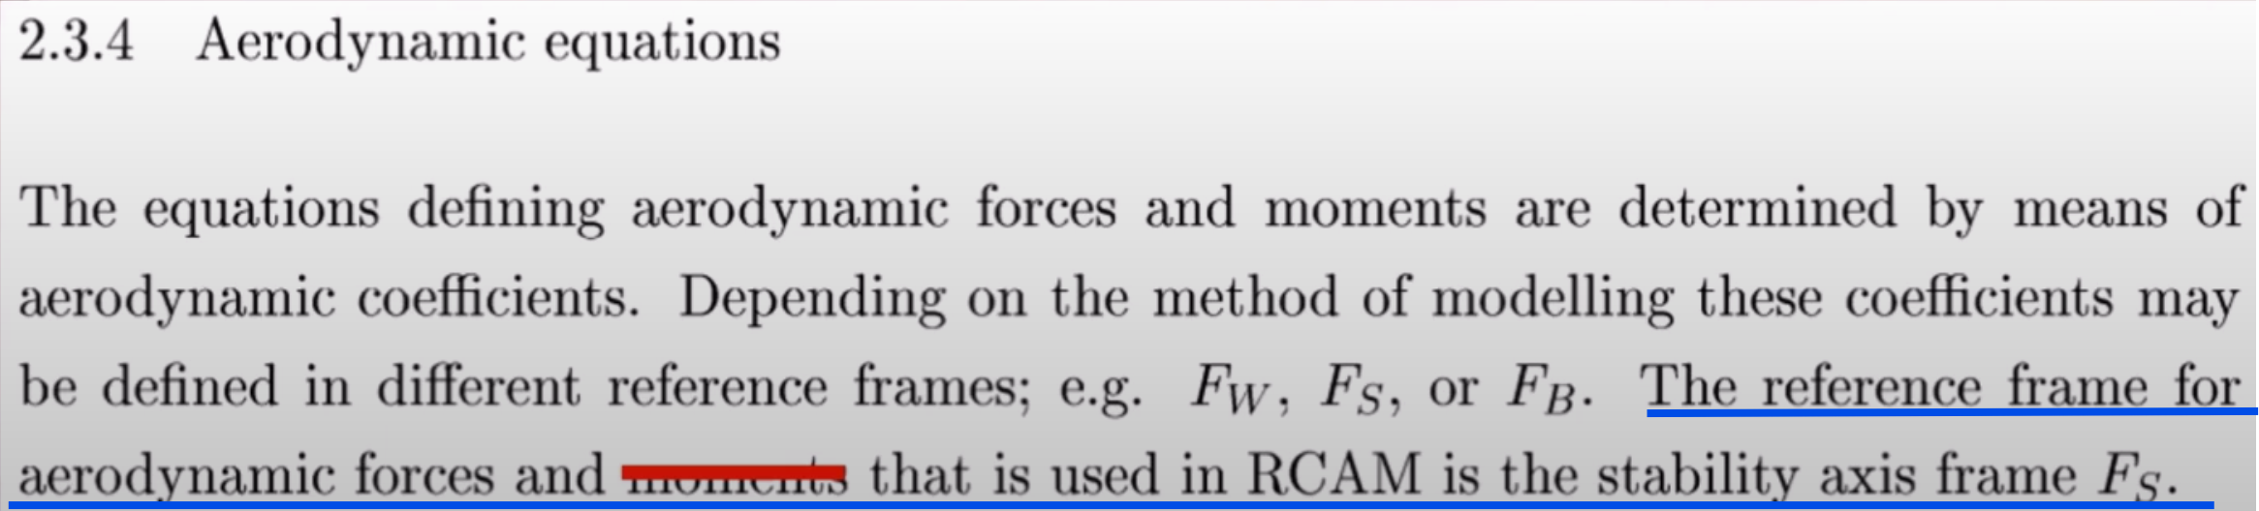

1. **Coefficient of Lift** (CL):
2. **Wing, Body consideration ${(C}_{L_{WB}})$:**

The coefficient of lift in the wing body frame is given by the piecewise function below:

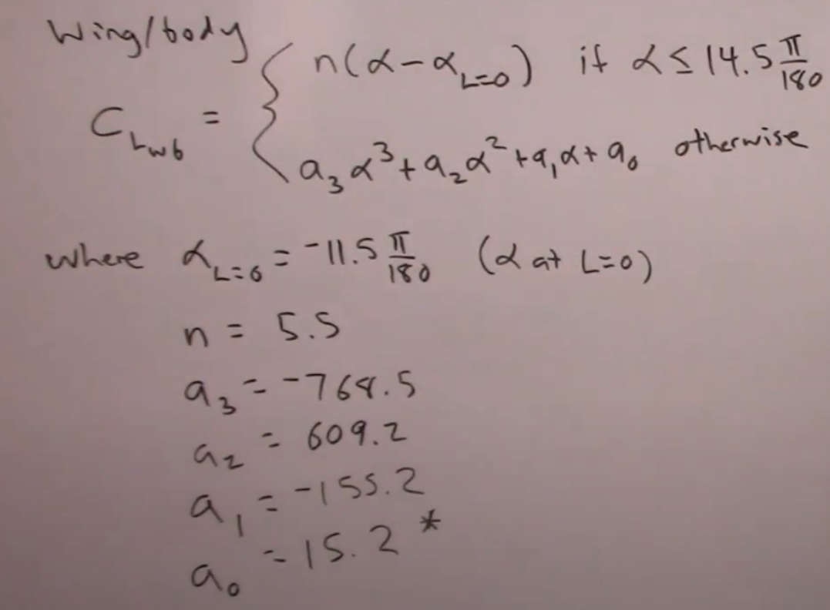

*(We will discuss in regard to the value of a0 in more detail later and that’s why it has a “*” symbol around it)*

Let’s try to understand whether the function mentioned above is reasonable for consideration and how is the function plotted below.

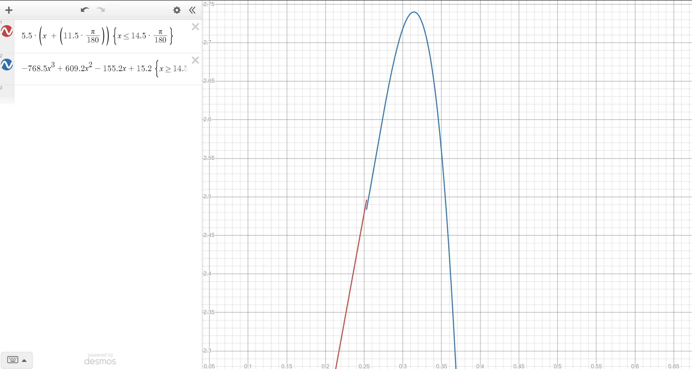

When the 2 curves are plotted, we see a discontinuity at the point α = 14.5*(π/180) rad.

So as to make the function continuous, the term a0 has to be made more accurate and hence we will be adding more numbers after the decimal place. The new value of a0 is:

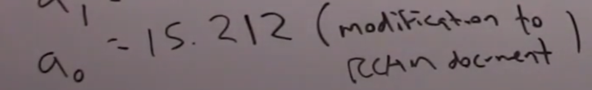

Which will in return give me the curve of $C_{L_{WB}}$ vs α as follows:

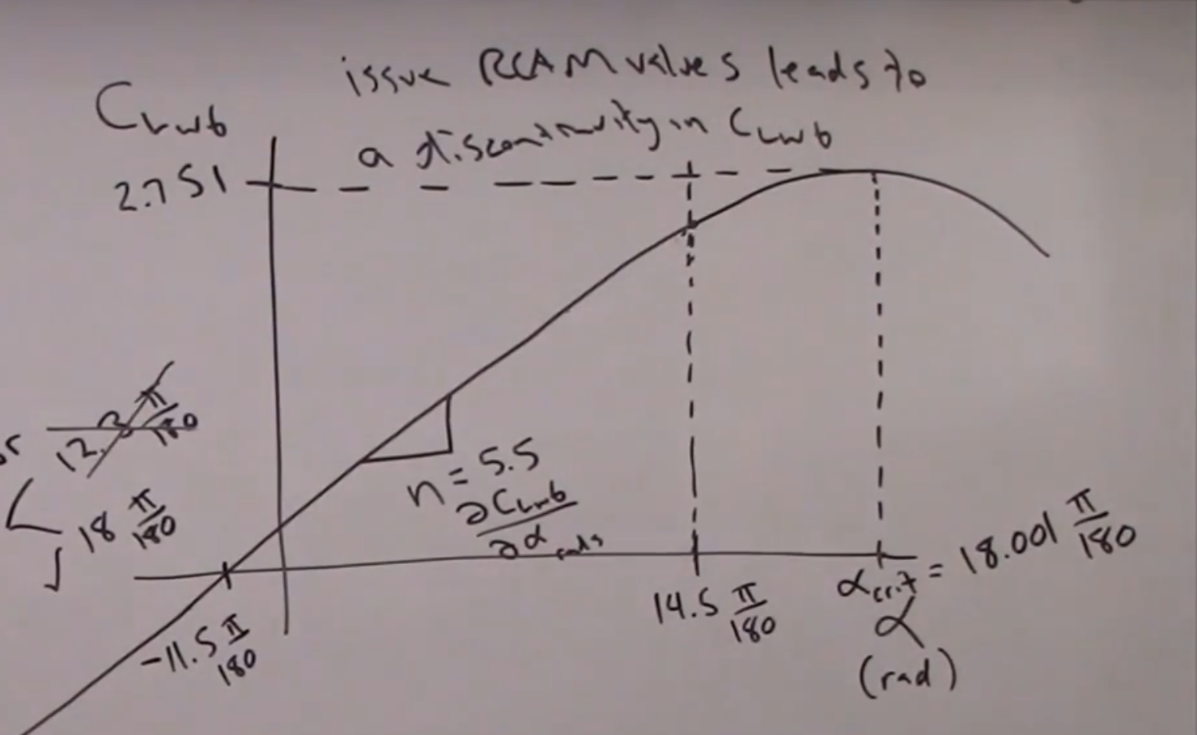

The critical value of the angle of attack can be found from making the slope of the cubic equation 0 and finding the points. We get 2 points and we must take the point that is after α = 14.5*(π/180) rad. The point obtained is α = 18.001*(π/180) rad and it produces a lift of 2.751.

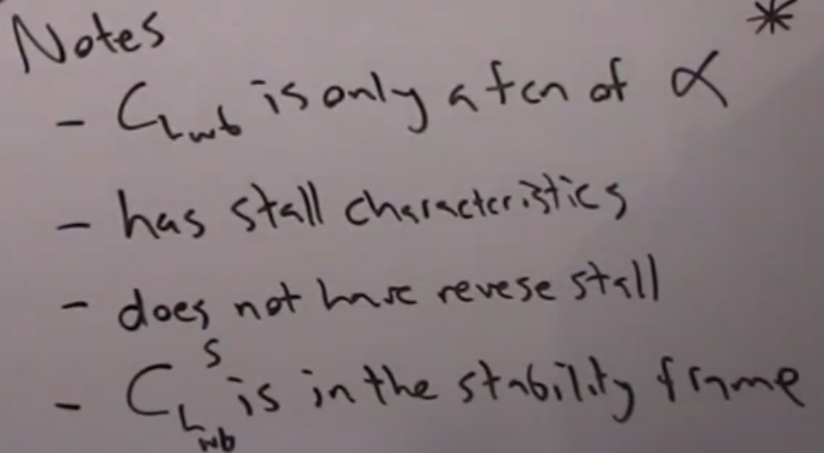

Here the dependency of sideslip angle isn’t considered to find the coefficient of lift effects. This will get deal

1. **Tail consideration ${(C}_{L_{T}})$:**

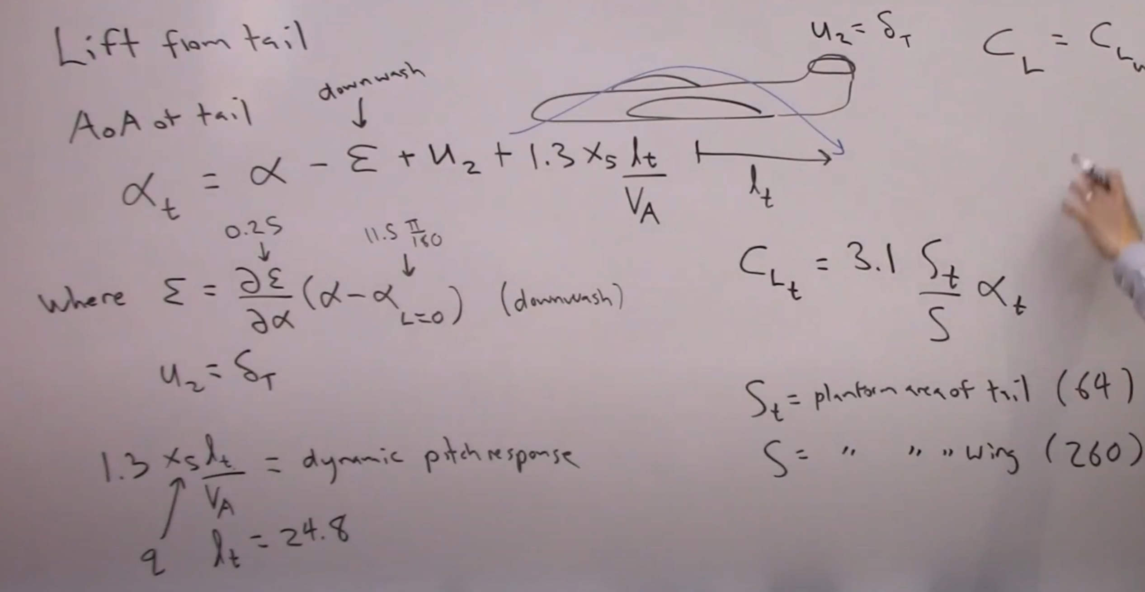

(**ϵ:** Change in angle of attack on the tail due to the lift generated by the wing.)

**(**11.5*(π/180) rad (As obtained from the curve of $C_{L_{WB}}$ vs α))

The net lift acting on the aircraft can be given as:

**NOTE: $C_{L}= C_{L_{T }}+ C_{L_{WB}}$**

1. **Coefficient of Drag** (CD)**:**

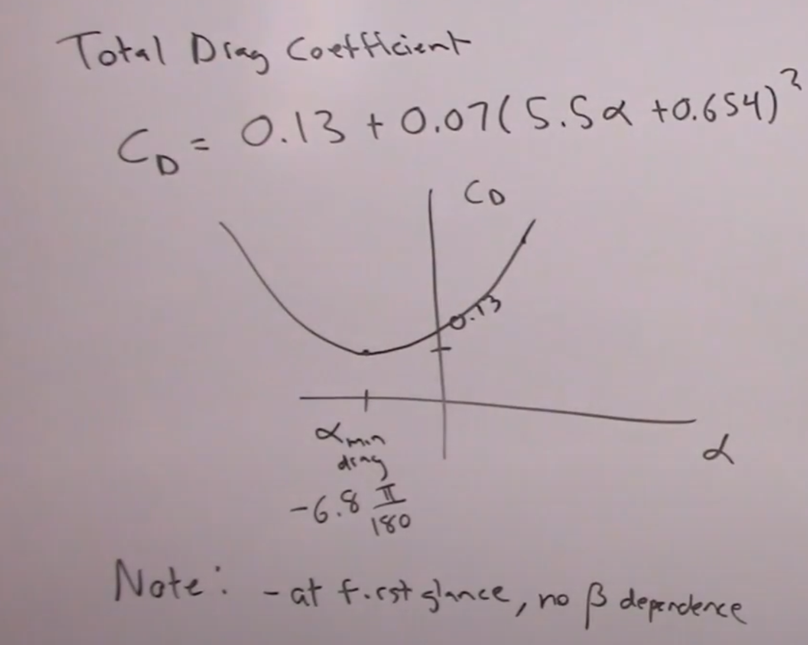

**NOTE:** We don’t see any terms with the sideslip angle because here the considerations are made with the consideration of the stability axis. When the discussion is moved to the wind axis, a more well-defined effect of sideslip angle will be seen.

1. **Coefficient of Side – force** (CY)**:**

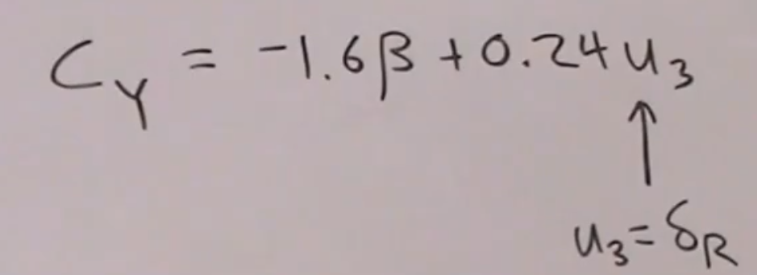

We will be able to see more effect of the rudder when we are modelling the equations for the yawing moment coefficient for the RCAM model.

**Rotation from the Stability frame to the wind frame:**

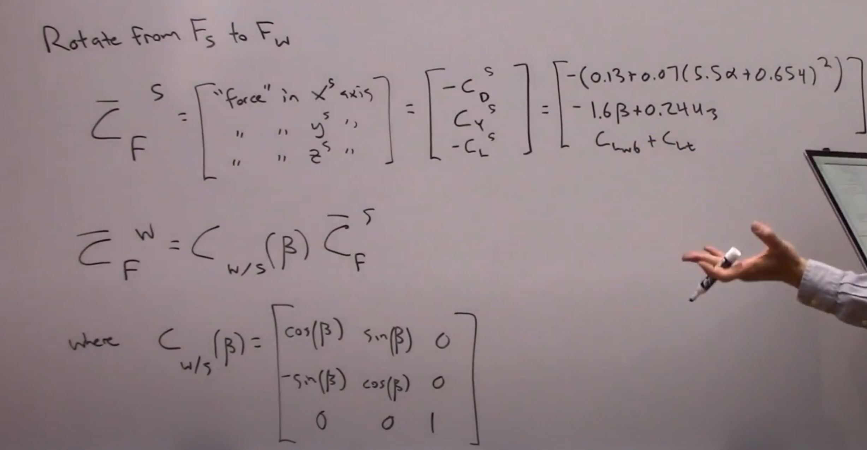

Let’s use the help of Mathematica to understand this matrix multiplication so as to get the final coefficients in the wind frame.

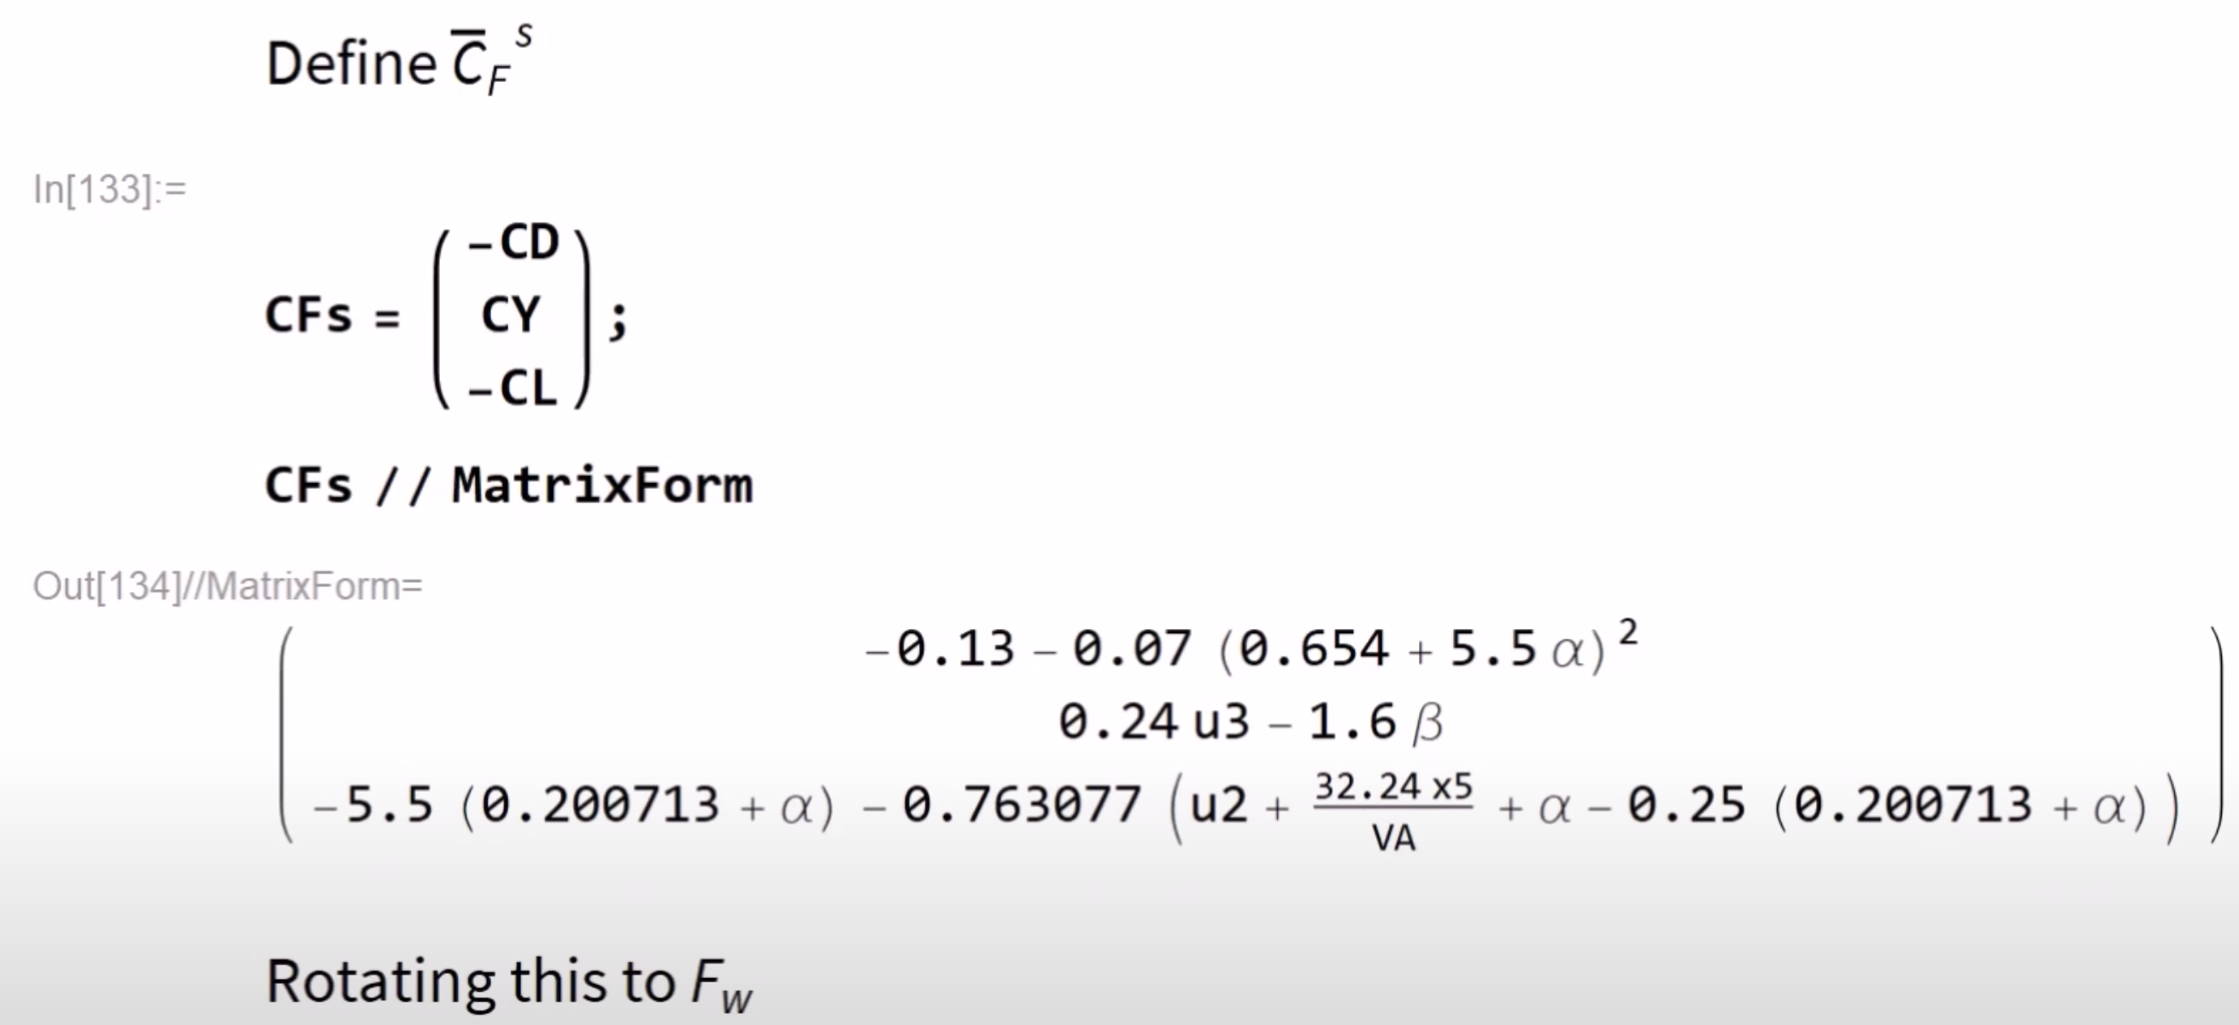

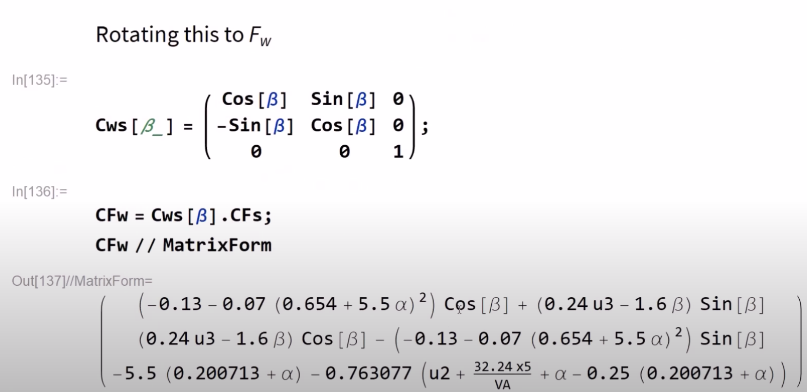

**NOTE:** To get to know the drag coefficient, it will be – (1,1) of CFw matrix.

To get to know the side – force coefficient, it will be (2,1) of CFw matrix.

To get to know the lift coefficient, it will be –(3,1) of CFw matrix.

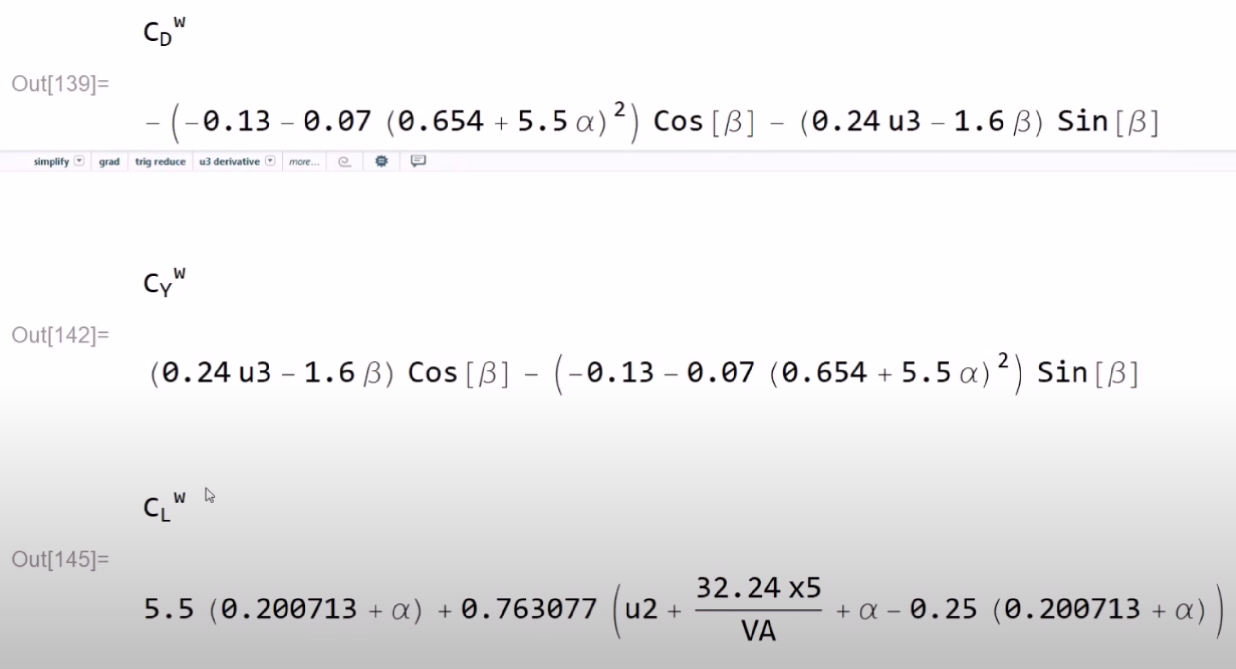

**NOTE:** There is no dependence of the sideslip angle in the CL modelling in RCAM.

1. **Aerodynamic Force in Fb:**

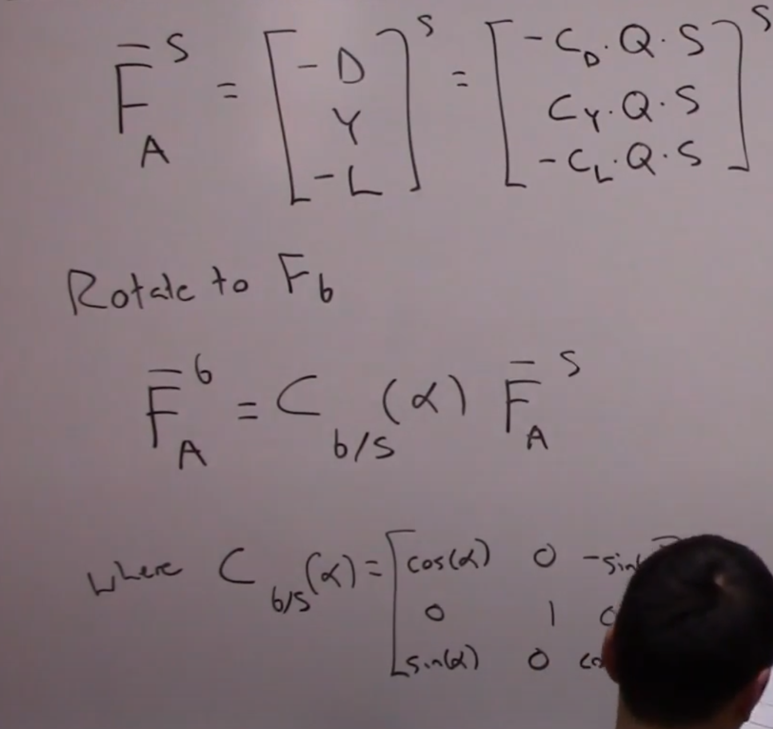

1. **Non-Dimensional Aerodynamic Moment Coefficient about Aerodynamic Centre in the Fb:**

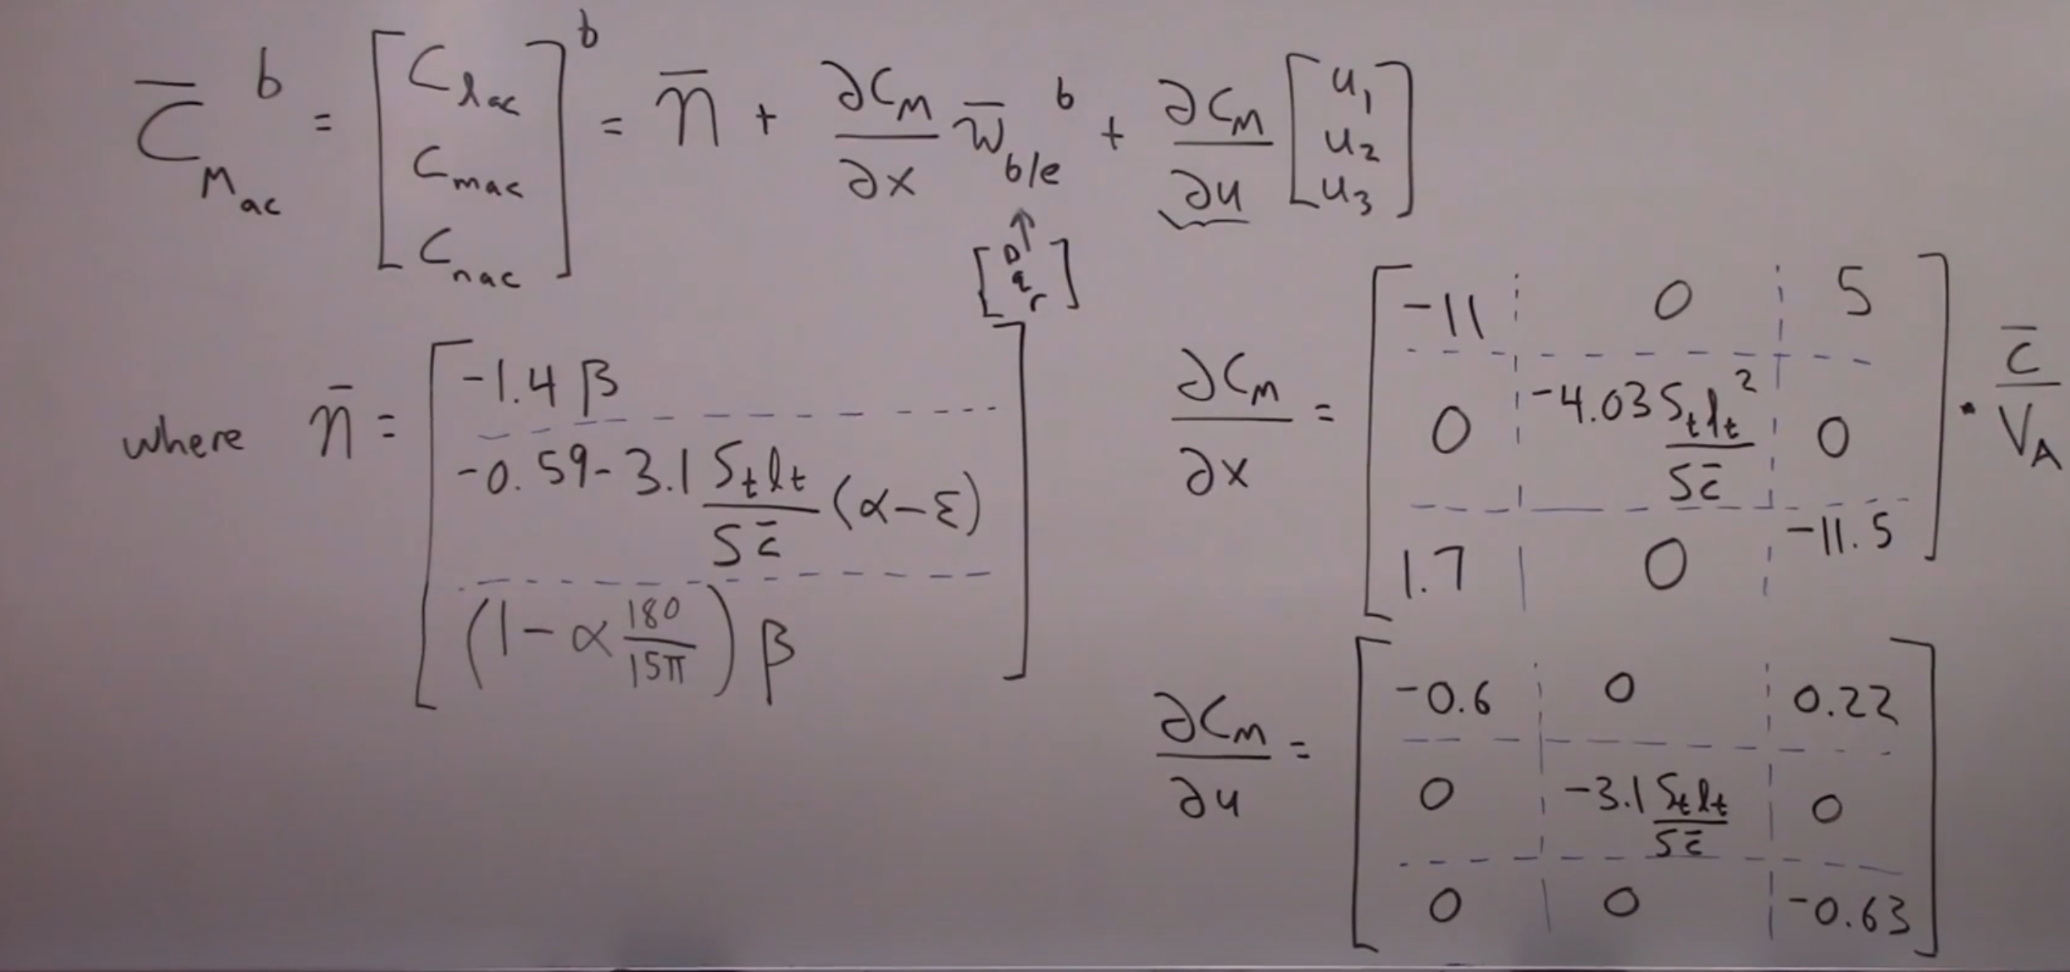

The 1st term in the RHS of the equation will give me the static stability component of the aircraft. The (2,1) element in the first terms is kept in such a way that there is static stability provided as the slope wrt the angle of attack is negative in nature which in turn gives stability. This can be seen from the graph shown below.

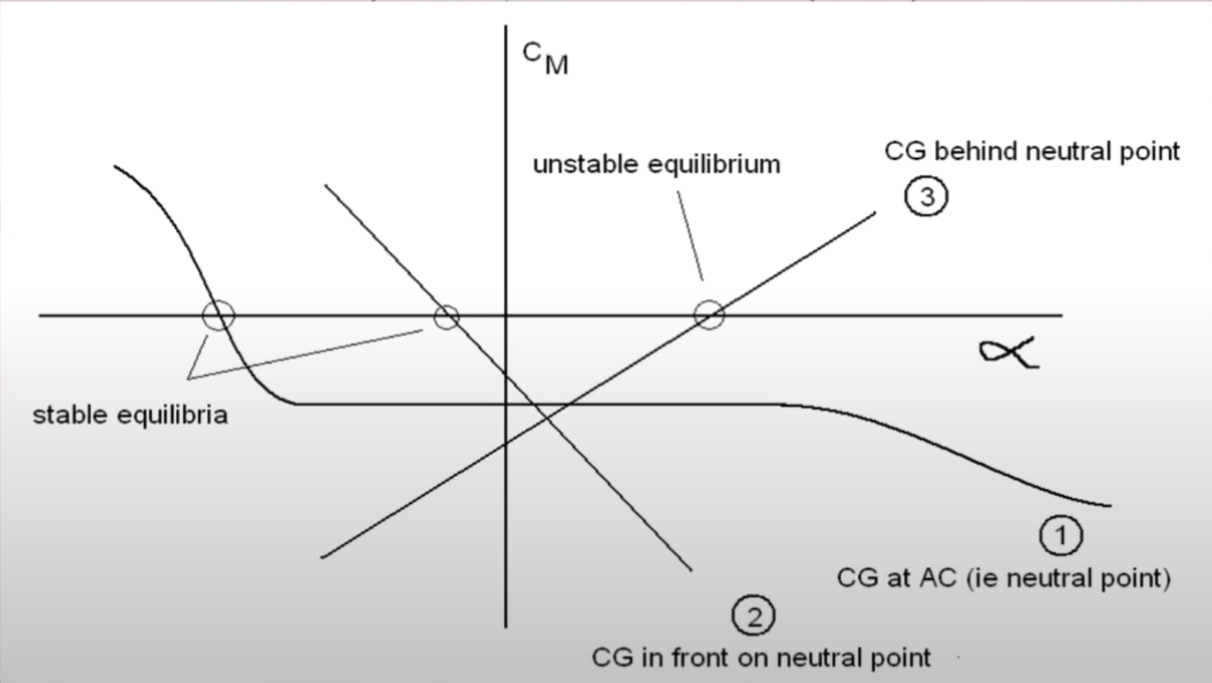

The 2nd term lets me know the dynamic angular rates behaviour which basically tells that if you have some non – zero angular velocities, you will induce some moments to the aircraft. These terms may dampen or exaggerate the angular velocities/angular rates.

The 3rd term measures the effectiveness of the control surface deflection in producing aerodynamic moments and lets me know if they do impart any kind of rolling, pitching or yawing moment.

1. **Aerodynamic Moment about the Aerodynamic Centre in Fb:**

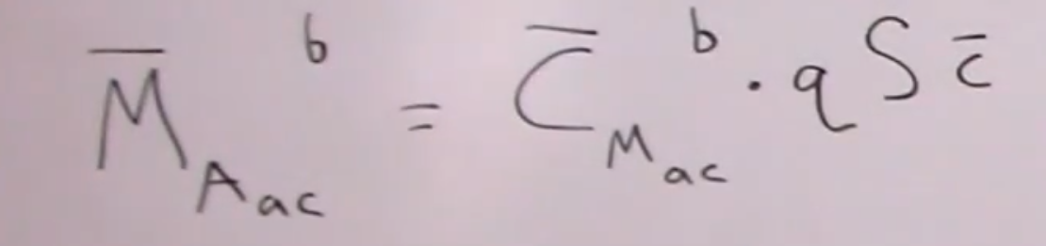

**NOTE:** Here q is “Q”

1. **Aerodynamic Moment about the C.G. in Fb:**

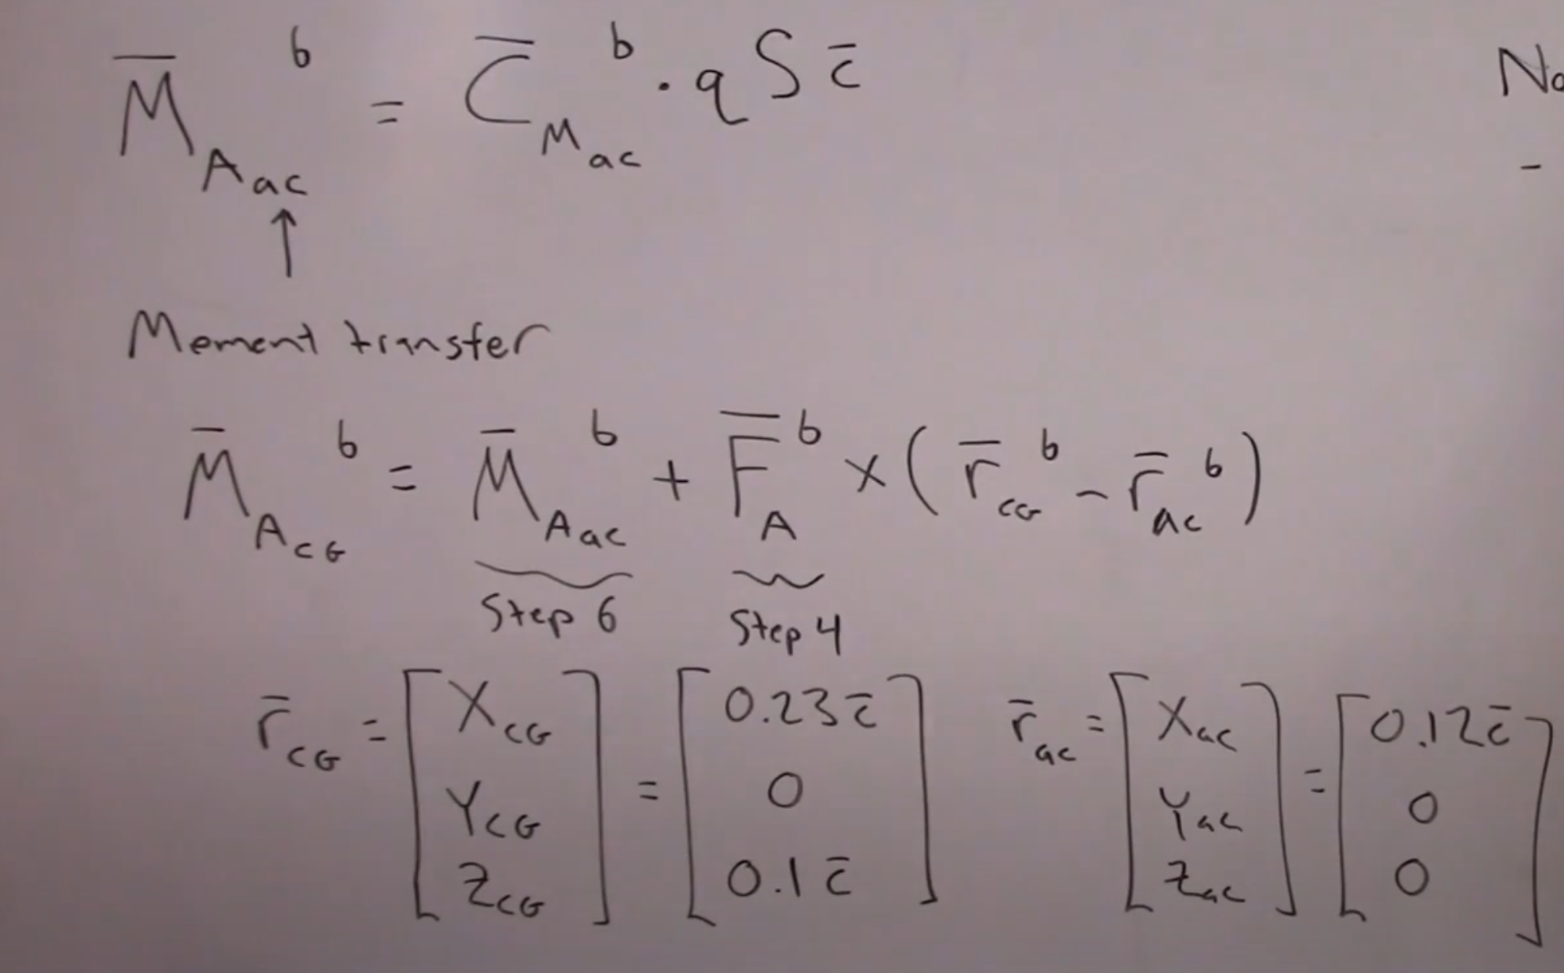

1. **Propulsion Effects:**

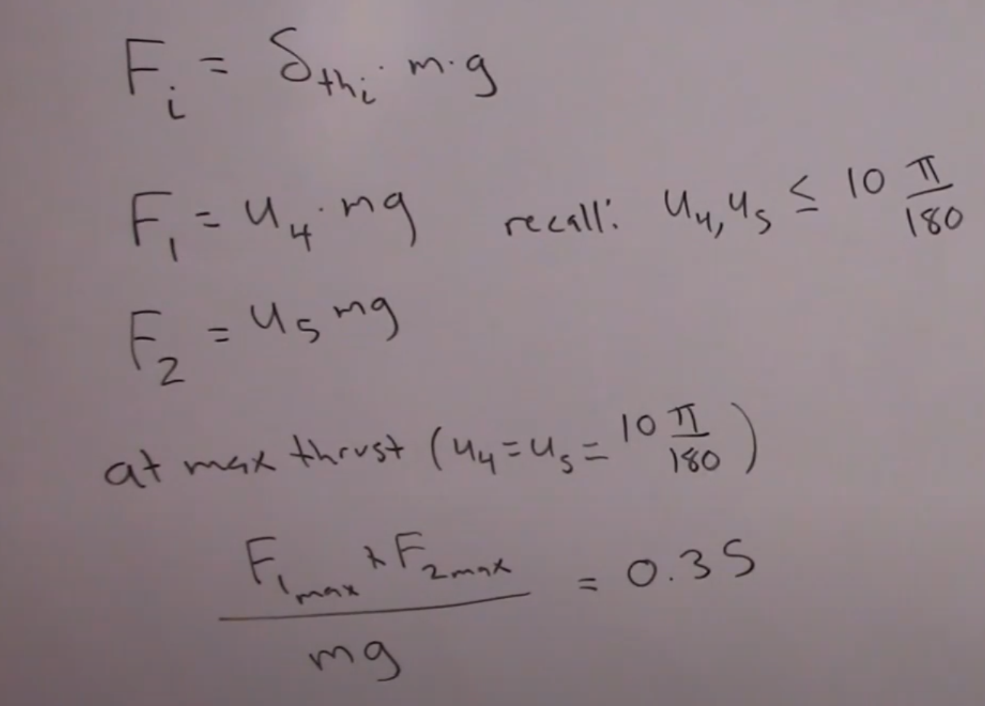

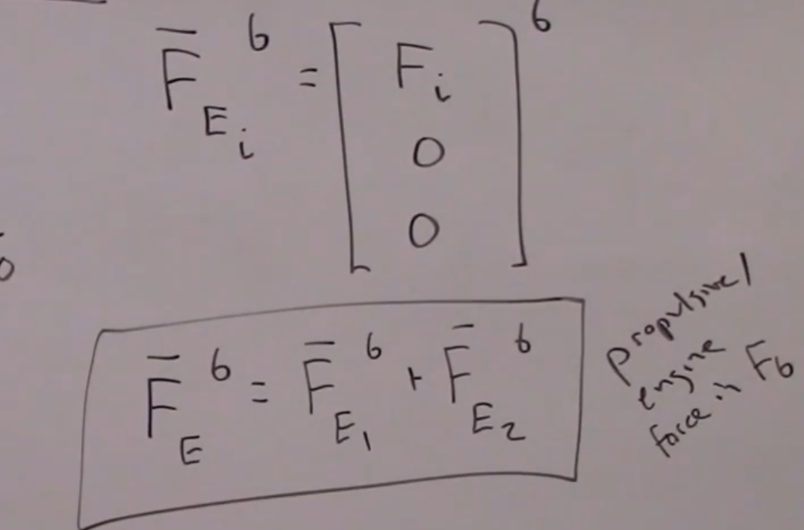

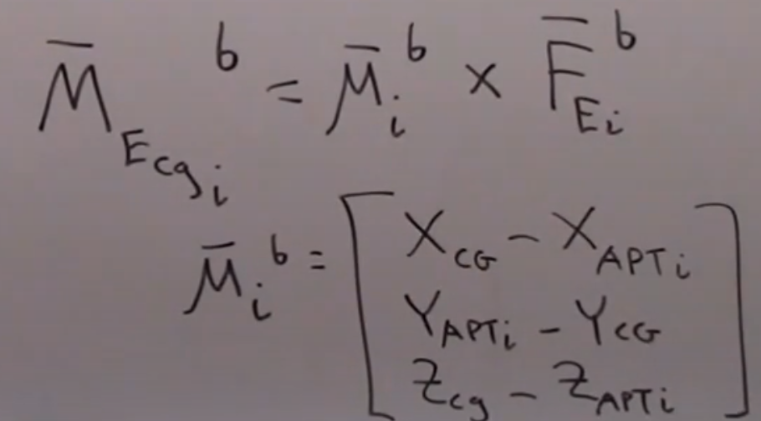

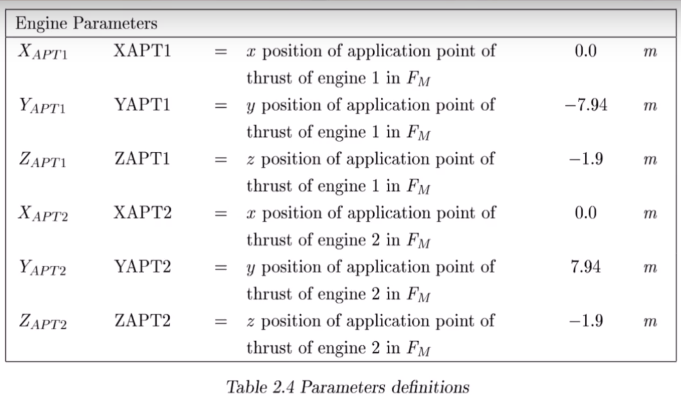

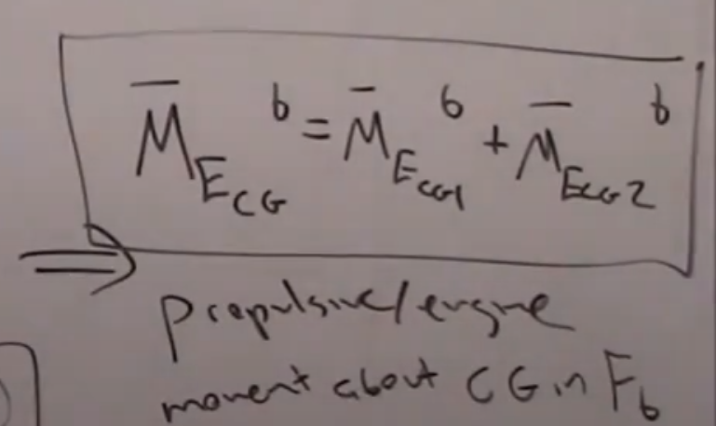

1. **Gravity Effects:**

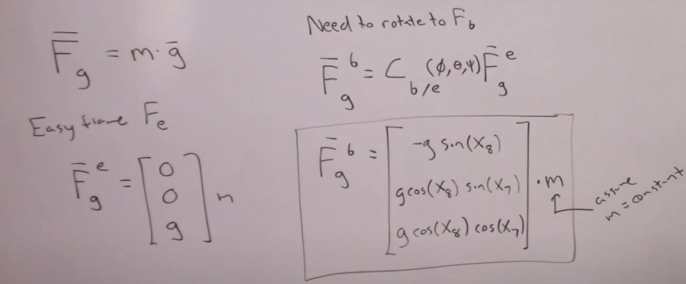

1. **Explicit First Order form:**

